Brainstorm document
Basic premise and goal of the game
Pvp racing game with grandmas where the goal is to escape death.
The goal of the game is to race to the end of the track, while being pressured by a timed wall of death. If a player stays in the wall of death for too long, they are eliminated. Whoever gets to the end first, wins. Everybody else is automatically eliminated, so only one grandma can win. If everyone is eliminated, death wins.
The feeling of the game is not very serious, though, the grandmas all understand and are not bitter about having to battle it out.

Engine choice
Unreal: to be able to use the megascans

Racing mechanics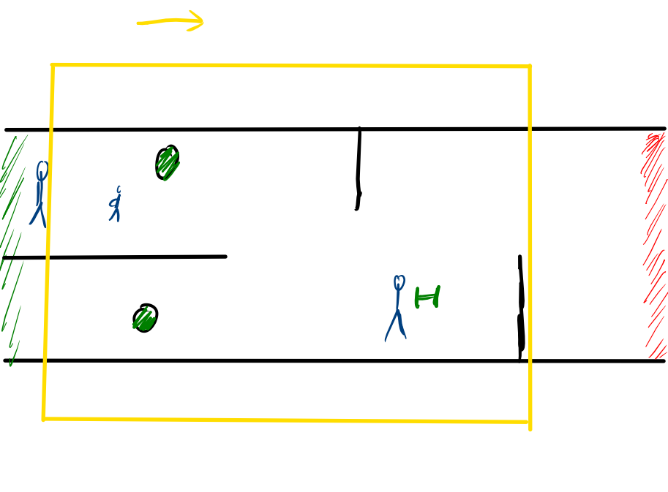
- Camera: perspective, tilted, sideview
- Controls:
  - Left-right: L joystick <- ->
  - Jump: L joystick up
  - Duck: L joystick down
  - Use item: ABXY
  - Aim: R joystick

World interaction
We can’t phase through platforms, you can duck to avoid projectiles

Item interaction
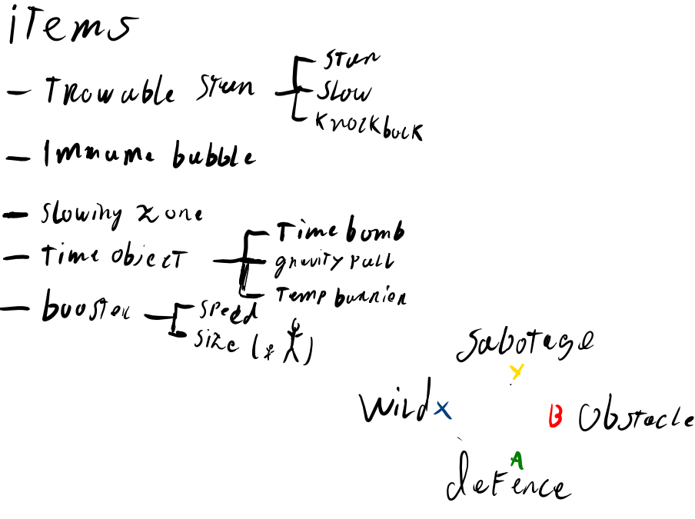

Item rules:
- Player can hold 4 items in total
- 1 of each category of items
- If a player has 4 items they can’t pick up any more

Characters and narratives
Characters are miniaturised puppet grandmas that drive wheelchairs or scooters. Each player can only choose one of the characters
 <- this kind of energy

UI for character selection
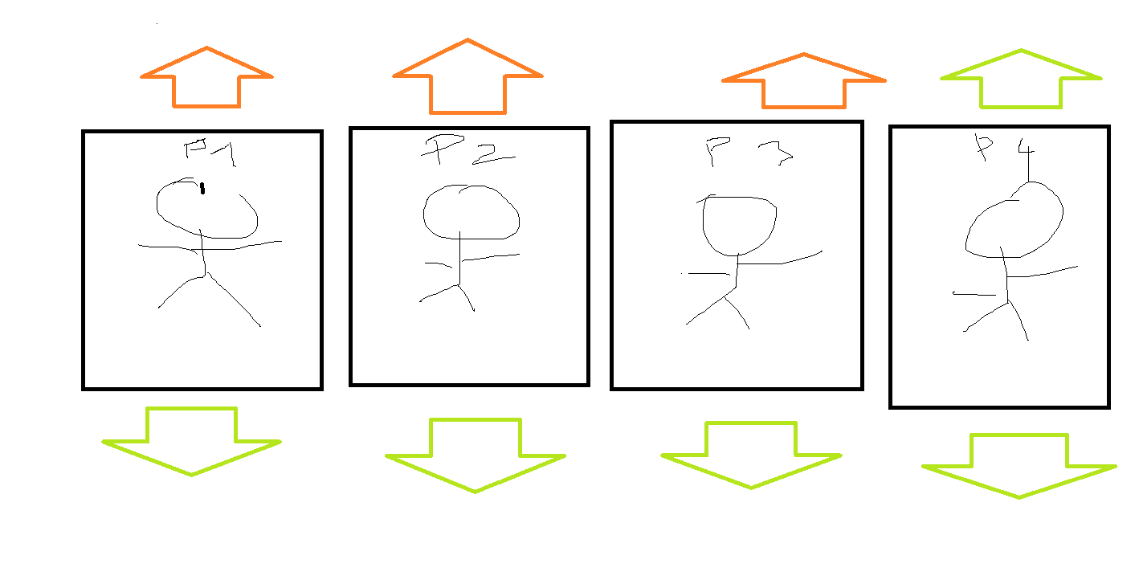

They’re escaping death by physically running from a representation of death
- Nurse
- Doctor
- Hospital bed with robotic arms
- Runaway train
- Reapers
- Hourglass on legs
- Sentient vacuum cleaner sucking up grandmas
- Sentient Knitting Balls
- Funeral crew
- Maybe their own mortal fears (representations of them)

The characters are made of little puppets and they have the souls of the grandmas in them.
The characters are small in a big environment.

Possible settings and environments
- Garden
- Retirement home
- Death’s workshop -> they’re running to the portal
- Running across the scrabble table
- Each part of the level is a part of the grandma’s life
- Dollhouse (where the proportions of the characters are normal)
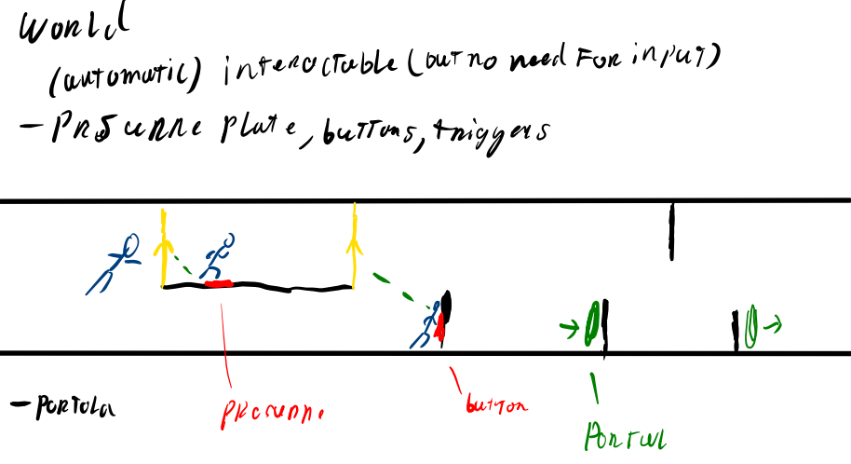

Possible name ideas:
- Not today, darling
- It ain’t today
- Escaping death

Possible extra game mechanics
- Revenge mechanic
- Line

